SMARTERSELECT CHEAT SHEET

- First time Screeners: Terry and Tish will send you an invite to establish your account on SmarterSelect (SS). Once you have established your account, remember to save your username and password for easy entry. SS has established new security features and will lock you out if you repeatedly try to log-in with incorrect information.
- Open www.SmarterSelect.com
- Click on sign-in. Follow the directions to set up your account.
- When you are ready to read the applications that have been assigned to you, open SS at: https://app.smarterselect.com and sign-in. If you haven’t saved your information, an alternative is to sign in with google.

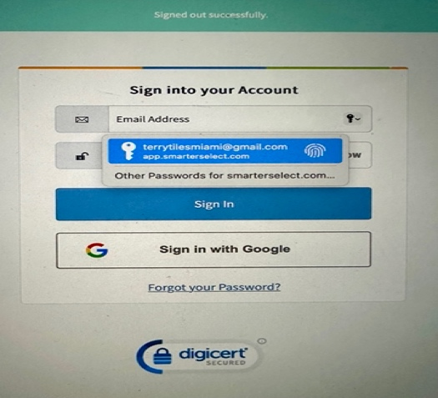

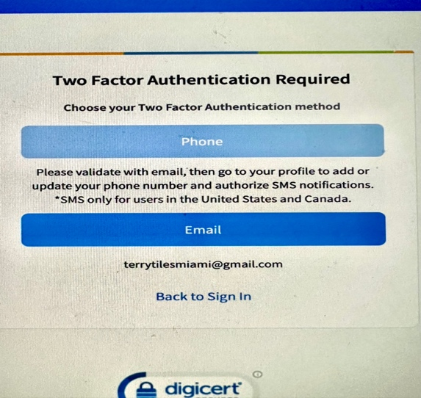
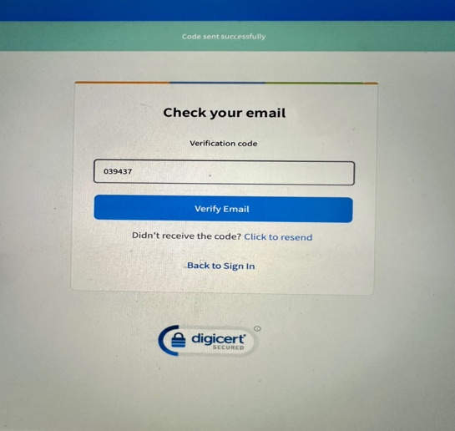

- SS requires two-factor authentication. Click on “email” to get a verification code.

- Copy and paste the code SS sends to your email to verify your email address.

- Now you’ll see your Welcome page. Click on the arrow next to the word “Evaluator”.

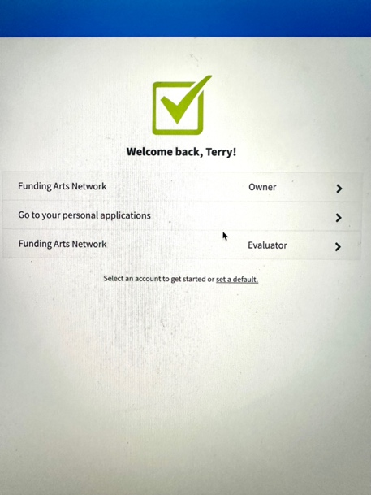

- Click on Applicants, in the gray box, top left.

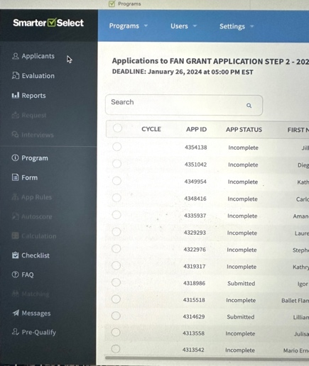

- On this screen, click on STEP 2 applications, second line down.

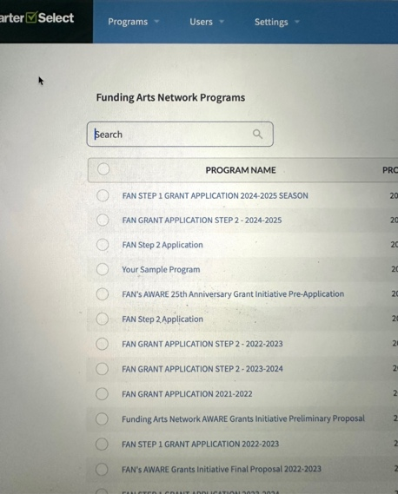

- Choose the application you want to read.

.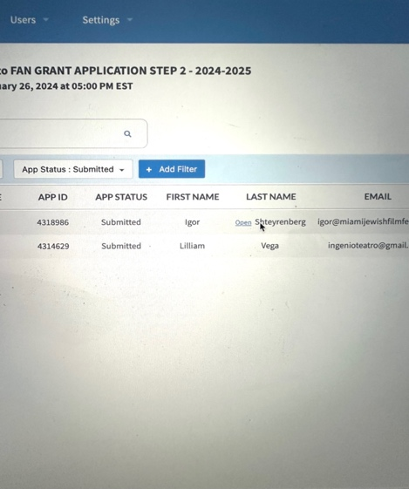

- In the menu bar on the right, you’ll see a few options. If you click on “Print as Applicant” you’ll see what the applicant sees. This version is harder to read and doesn’t print well. So, the better option is to choose “Print as Provider” to easily read, save, and print the application. Printing the application and taking it to your site visit will help organize your thoughts and observations.
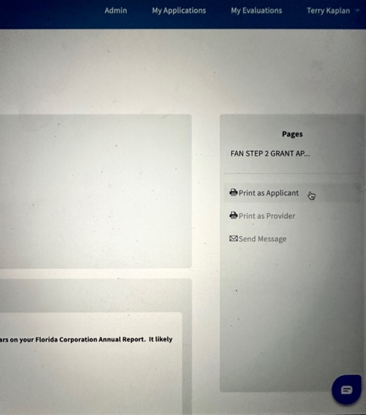

- To read attachments such as financial, logos, etc., go to the Applicant View and click the “eye” icon or “cloud” icon to download.



- Last and yet most important is your evaluation. Located at the end of the grant application, it is easy to find because all your questions have a blue background. Screening partners will agree on whether to submit one joint evaluation or separate evaluations. Either way, don’t forget to click Submit.

